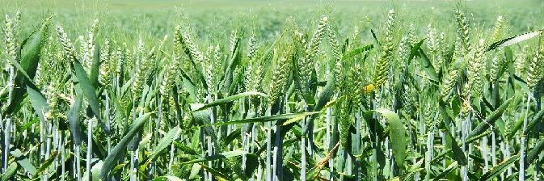
AZOVATI
Bacteria used: Azotobacter species
About the bacteria: Azotobacter species are gram-negative, free-living, nitrogen fixing bacteria which can fix atmospheric molecular nitrogen without any symbiotic relationship with the plants and release nitrogen in the form of ammonia into the soil.
Use in agriculture: This bacteria is widely used as nitrogen bio-fertilizer for sustainable agriculture
Our product: We are glad to introduce AZOVATI both in liquid and powder form which have 100 to 110 times (x10¹⁰ to x10¹¹) more Azotobacter than normal growth which can fix 30-50% more nitrogen is higher than many other products available in the market and also confirms more efficiency and cost effective. In very low dose it can cover major area of land or more plants or seeds.
Specifications of our product: Our this product is developed on our patented technology where we get at least 20 times more bacterial colonies after 72hours of inoculation just using a noble media ingredient(patent pending) material in this product which is non hazardous to environment. This rapid bacterial growth will also help farmers to control pathogenic fungal and other bacterial diseases to plants.
Application doses and methodology: Both liquid and powder can be used as soil application, seed priming, foliar spraying in regulated doses of application determined for specific plant species.
DOSES:
For field crops: 15 kg per Hectare
- Soil Application: 7 kg
- 1st foliar spray: 4 Kg
- 2nd foliar spray: 4 Kg

For nursery plants: 20 Kg per 1000 seedlings
- Soil Application: 15 kg
- Foliar Spray: 5 kg

For Soil Apllication: To get the best result 3 split doses should be applied for each crop.
First Split Dose: It is applied for soil. For soil application, required amount of AZOVATI should be mixed with dried and ground organic manure or soil and broadcast on the field just before transplantation or sowing of the seeds.
Second and Third Split Doses: These doses are foliar spray doses should be applied at the time of maximum vegetative growth and flowering. For foliar spray, required amount of AZOVATI should be poured in a cloth bag and the bag should be kept immersed in water in a suitable container for few hours. After the dilution of bacterial suspension with required amount of water (300 – 400 litre per hectare) and is sprayed on the foliage preferably after sundown.
Precautions:
1. Keep it out of reach of children and do not swallow it. Always rinse hands with soap after using it. Better to use gloves.
2. Do not mix AZOVATI with any chemical pesticides. For best results, do not use AZOVATI and chemical fertilizers on the same day. Keep packets of AZOVATI in a cool place away from sunlight.
3. Once the packet is opened, use the whole amount of AZOVATI in the same day and use it before expiry date.

