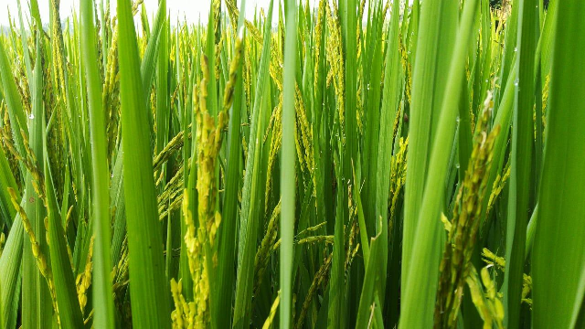

NPKVATI NPK Consortia

INVATI presents powered composite culture of Nitrogen fixing bacteria Azotobacter, Phosphate solubilizing bacteria, Potash mobilizing bacteria which is 20X stronger than any other biofertilizer due to the patented growth media of this NPK consortia. We are glad to introduce this NPK consortia power both in liquid and powder form which have 100 to 110 times (x10¹⁰ to x10¹¹) more bacteria than normal growth which can fix 20-30% more nutrients in available form to plants, which is higher than many other poroducts available in the market and also confirms more efficiency and cost effective. In very low dose it can cover major area of land or more plants or seeds.
NPK consortia: hand in hand with nature
Nature provides a number of useful soil micro-organisms which can help plants to absorb nutrients. Their utility can be enhanced with human intervention by selecting efficient organisms in their living or dormant forms, culturing them and adding them to soils directly or through seeds. The cultured micro-organisms packed in some carrier material or liquid media are applied to crops to provide nutrients in usable form. NPK Consortia application help in fixing atmospheric nitrogen or solubilise / mobilise soil nutrients & secrete growth promoting substances for enhancing crop growth.
Other Specifications of our product:
OurNPK consortia product is developed on our patented technology where we get 20 times more bacterial colonies after 72hours of inoculation just using a material in this product which is non hazardous to environment. This rapid bacterial growth will also help farmers to control pathogenic fungal and other bacterial diseases to plants.

The NPK consortia power contains following bacteria:
(1) Nitrogen fixing bacteria, Azotobacter (free living):
Atmosphere contains 78% nitrogen which is a very important nutrient for plant growth. Azotobacter fixes about 20-30 kg atmospheric nitrogen / ha in the soil and makes it available to the plants. It protects the roots from other pathogens present in the soil.

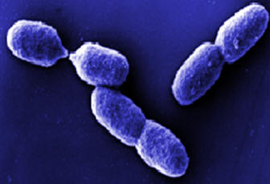

(2) Phosphorus solubilising bacteria (PSB):
phosphate solubilizing bacteria in soils is needed to restore and maintain the effective microbial populations for solubilization of chemically fixed phosphorus as well as availability of other macro and micronutrients to harvest good sustainable yield of various crops. It releases insoluble phosphorus in soil and fix this phosphorus in clay minerals which is of great significance in agriculture e.g. Bacillus, Pseudomonas, Aspergillus etc.

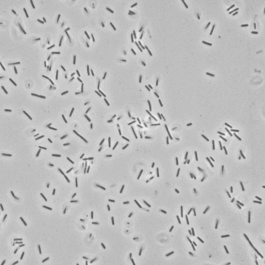

(3) Potash mobilising bacteria (PMB):
It mobilises fixed potassium in soil and plays a vital role in plant potassium nutrient uptake e.g. Frateuria aurantia

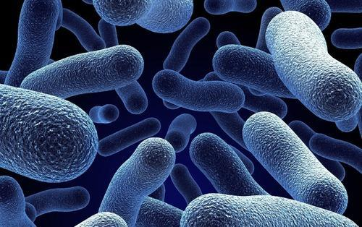

Advantages of NPK Consortia
- NPK Consortia is cost effective & eco-friendly.
- NPK Consortia provide growth-promoting factors to plants through secretion of different vitamins, phytohormones and by successfully facilitating composting and controlling attack of pest and soil borne diseases
- NPK Consortia increase the nutrient availability and therefore impart long term sustainability to crop production.
- NPK Consortia impart better health to plants and soil thereby enhancing crop yields in a moderate way (up to 20 – 25 %)
- NPK Consortia is a natural method without any problems like salinity and alkalinity, soil erosion etc.
- NPK Consortia will be a boon for vast areas of low input agriculture and oil seeds production, as also in crops like sugarcane, etc, these products will be of much use to give sustainability to production.

Application doses and methodology: We have both liquid and powder can be used as seed priming in regulated doses of application determined for specific leguminous plant species.
Application doses and methodology:
For field crops: 20 kg per Hectare / liquid 6 litres per hectare
- 1st Soil Application: 10 kg / 3 litres
- 2nd Soil Application: 5 Kg / 1.5 litres
- 3rd Soil Application: 5 Kg / 1.5 litres

For nursery plants: 15 Kg / liquid 4.5 litre per 1000 seedlings
- 1st Soil Application: 10 kg / 3 litres
- 2nd Soil Application: 5 kg / 1.5 litres

For Soil Apllication: To get the best result 3 split doses should be applied for each crop.
First Split Dose: It is applied for soil. For soil application, required amount of NPK power should be mixed with dried and ground organic manure or soil and broadcast on the field just before transplantation or sowing of the seeds.
Second and Third Split Doses: Repeat the same procedure as in the First Split dose.

Precautions:
1. Keep it out of reach of children and do not swallow it. Always rinse hands with soap after using it. Better to use gloves.
2. Do not mix NPK Consortia power with any chemical pesticides. For best results, do not use NPK Consortia power and chemical fertilizers on the same day. Keep packets of NPK Consortia power in a cool place away from sunlight.
3. Once the packet is opened, use the whole amount of NPK Consortia power in the same day and use it before expiry date.
4. The liquid NPK consortia power will be used fully after opening the bottle @ specified doses mixed with appropriate volume of compost materials.

