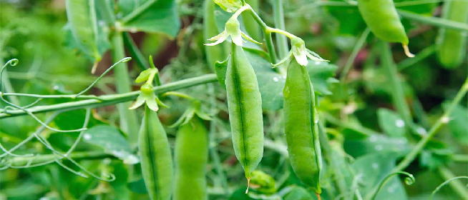
RHIZOVATI power
Bacteria used: Rhizobium species
About the bacteria: Rhizobium species are gram-negative, soil bacteria which can fix nitrogen in presence of symbiotic association with the roots of legume plants and convert atmospheric nitrogen into ammonia with the help of nitrogenase enzyme and this association would also leave residual soil nitrogen for the succeeding crop.
Use in agriculture: This bacteria is particularly used as nitrogen bio-fertilizer for legume crop cultivation.
Our product: We are glad to introduce RHIZOVATI power both in liquid and powder form which have 100 to 110 times (x10¹⁰ to x10¹¹) more Rhizobium than normal growth which can fix 30-45% more nitrogen is higher than many other poroducts available in the market and also confirms more efficiency and cost effective. In very low dose it can cover major area of land or more plants or seeds.
Specifications of our product: Our this product is developed on our patented technology where we get 20 times more bacterial colonies after 72hours of inoculation just using a nano material in this product which is non hazardous to environment. This rapid bacterial growth will also help farmers to control pathogenic fungal and other bacterial diseases to plants.
Application doses and methodology: We have both liquid and powder can be used as seed priming in regulated doses of application determined for specific leguminous plant species.
DOSES:

Seed treatment Procedure: 2 kg RHIZOVATI for seeds required per hectare.
Methodology:
For Seed Treatment: Mix required quantity of RHIZOVATI with small amount of water to make it slurry like mixture. Then add washed seeds required for 1 hectare of land in it and mix nicely so that there should be a thin coat over the seeds and then dry the seeds under shade before sowing.
Precautions:
1. Keep it out of reach of children and do not swallow it. Always rinse hands with soap after using it. Better to use gloves.
2. Do not mix RHIZOVATI with any chemical pesticides. For best results, do not use RHIZOVATI and chemical fertilizers on the same day. Keep packets of RHIZOVATI in a cool place away from sunlight.
3. Once the packet is opened, use the whole amount of RHIZOVATI in the same day and use it before expiry date.
